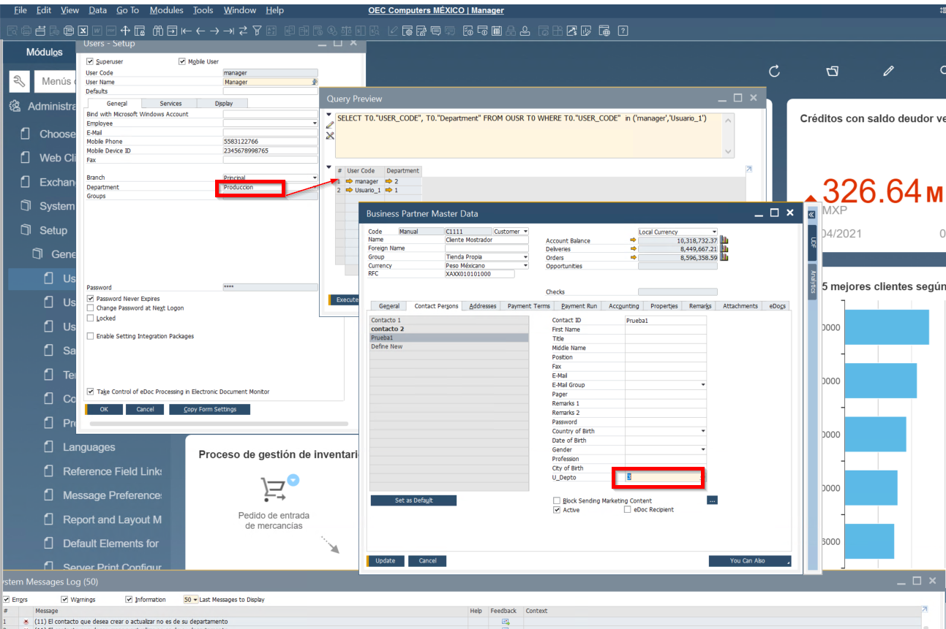 | En Update o Creación retorna el mensaje correcto:  (11) El contacto que desea crear o actualizar no es de su departamento
ALTER PROCEDURE SBO_SP_TransactionNotification
(
in object_type nvarchar(30), -- SBO Object Type
in transaction_type nchar(1), -- [A]dd, [U]pdate, [D]elete, [C]ancel, C[L]ose
in num_of_cols_in_key int,
in list_of_key_cols_tab_del nvarchar(255),
in list_of_cols_val_tab_del nvarchar(255)
)
LANGUAGE SQLSCRIPT
AS
-- Return values
error int; -- Result (0 for no error)
error_message nvarchar (200); -- Error string to be displayed
cnt int;
Departamento NVARCHAR(2);
UsuarioSap nvarchar(255);
begin
error := 0;
error_message := N'Ok';
---------------------------------------------------------------------
-- ADD YOUR CODE HERE
---------------------------------------------------------------------
-- Personas de contacto x departamento --
IF :object_type= '11' AND (:transaction_type in( 'A','U','D') )
THEN
SELECT "UserSign" INTO UsuarioSap FROM OCPR WHERE "CntctCode" = list_of_cols_val_tab_del;
SELECT COUNT (*) INTO cnt FROM OCPR T0
INNER JOIN OUSR T1 ON T0."UserSign" = T1."USERID"
INNER JOIN OCRD T2 ON T0."CardCode" = T2."CardCode"
WHERE T0."U_U_Depto" <> T1."Department"
AND T0."UserSign"= UsuarioSap
AND T0."CntctCode" = list_of_cols_val_tab_del;
IF :cnt > 0 THEN
error := 11;
error_message:='El contacto que desea crear o actualizar no es de su departamento';
END IF;
END IF;

 | Ahora al momento de borrar el contacto del departamento
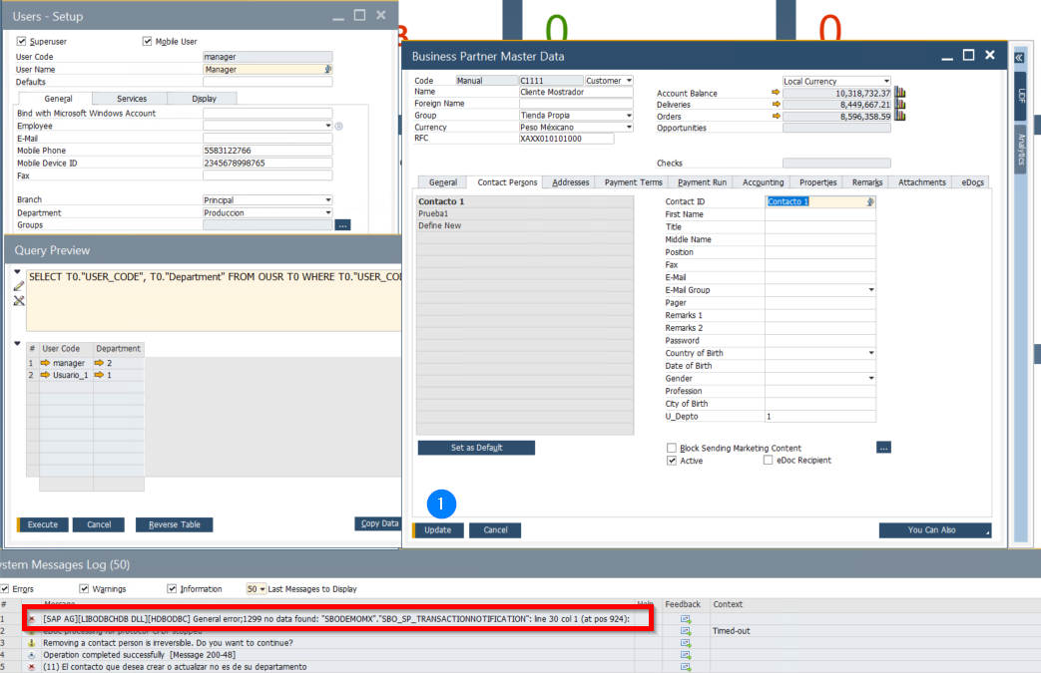 | [SAP AG][LIBODBCHDB DLL][HDBODBC] General error;1299 no data found: "SBODEMOMX"."SBO_SP_TRANSACTIONNOTIFICATION": line 30 col 1 (at pos 924):

